**S4 Assignment-Topics in Programming**

**P.Vishnu Vardhan.**

1. Data base = simply to store data.

Types of data bases to store data are namely,

1.Relational

2.Coloumnal

3.No-SQL

4.Hierarchical

5.Document.

Every data base is as good as it, in its own way.

Among all these we mostly use two types-based orientation of data stored namely relational (SQL) and No-SQL.

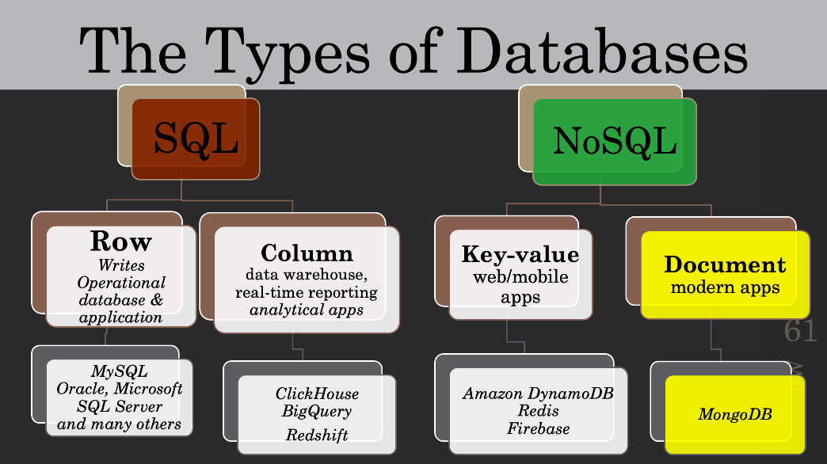

What is NO-SQL?

Also called as NON-RELATIONAL DATA BASE

It stores the data not in tabular format.

In this the data stored based on Key-value and document type.

For internet and computer and online based applications this data base is more convenient to use than SQL.

Cannot use ACID transactions.

More flexible and integrated.

Easy to scale

Fast to read than SQL data base.

Cannot use ACID transactions. Partial ACID.

In this there is no data restriction and relational ship of the data.

Light weight developers use NO-SQL.

Used for real time performers.

What is SQL?

Also called as RELATIONAL DATA BASE.

Its stores the data in tabular format i.e., the data stored in row wise and column wise.

It is popular for its ease of updating and rewriting data for operational data base and applications.

If you want to do the CURD(Create, Update, Read and Delete) operations then you must choose the SQL data base.

Used for ACID Transactions, that means

A-Atomicity

C-Consistency

I-Isolation

D-Durability

Restrict on data Relational ship.

Heavy model tasks adopt relational.

It also have data schema and makes so good to use.

Comparing the database types in terms of

**Popularity: -**

These are some of the popular databases shown below.

In connection with the popularity they again divided or categorized according to cost wise and usage wise.

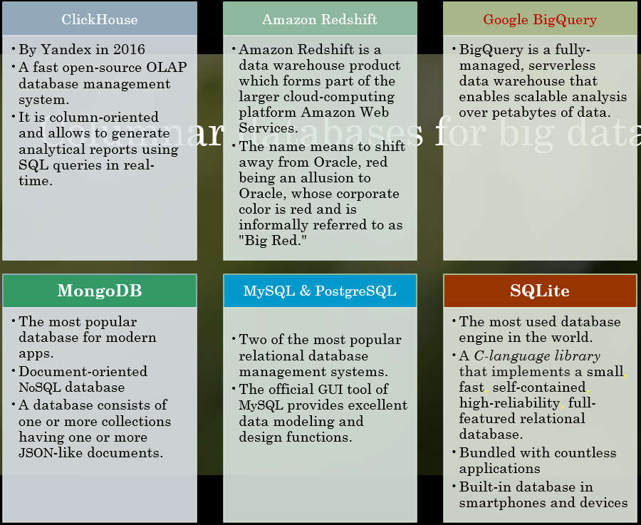

When compare with the most popular,

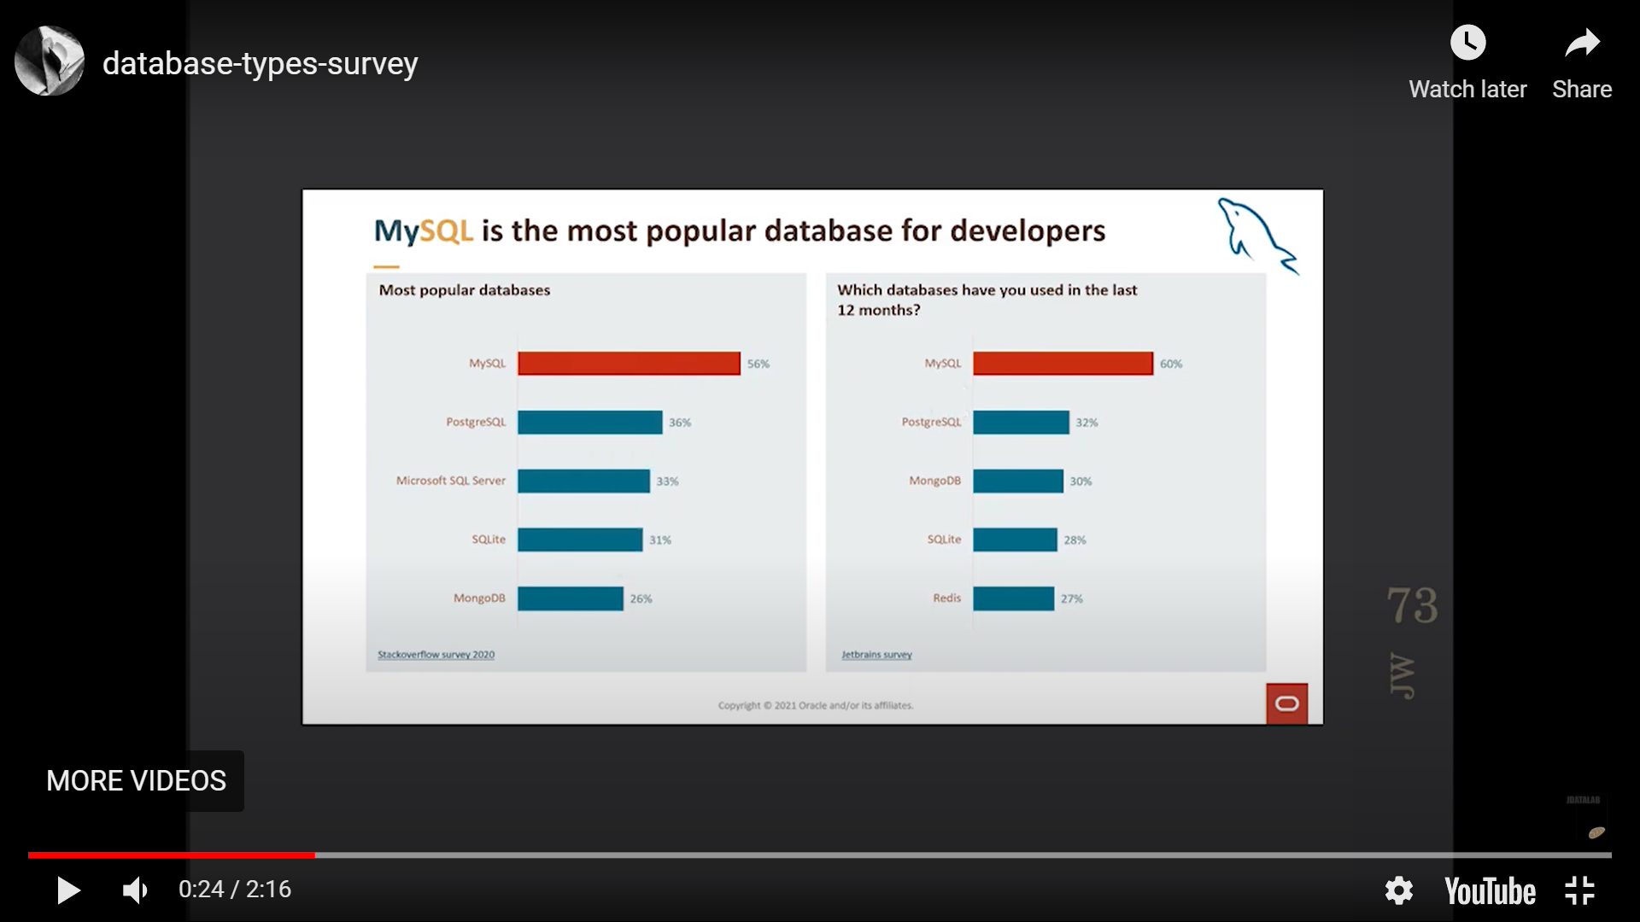

The above survey is based on 2 years, in 2020 the MYSQL is used by 56% of the people and next to it PostgreSQL took the second position.

Coming to the next year i.e., 2021 MYSQL again heads up with almost 60% of users and keeps continuing. That means that remarkable the MySQL sever gives a lot of facilities and also a best infrastructure and retains its place.

Even MongoDB is also gaining its importance gradually in the year 2020 the users percentage is almost 26% and now in 2021 the users grow up to 30% and keeps continuing.

The other server details are mentioned above in the slide.

SQL

SQL

SQL

SQL

NO-SQL

NO-SQL

SQL

Hosted

NO-SQL

NO-SQL

Key-value, document type

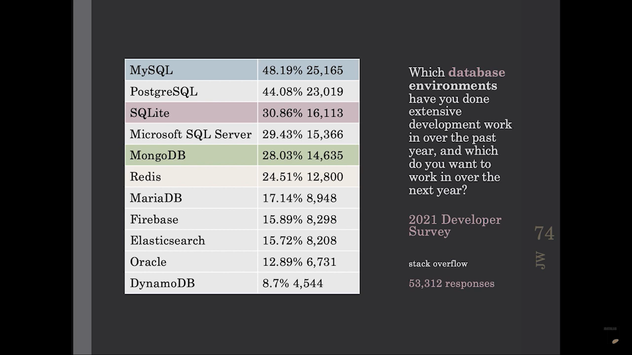

These are some of the data bases used in terms of percentages and number of developers working with respective databases.

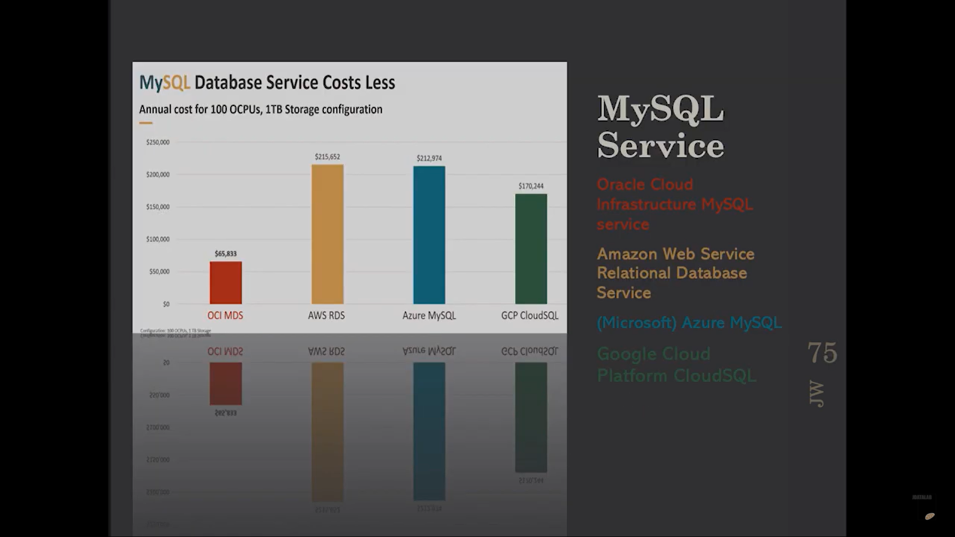

These are some of the data bases which popular and costs accordingly,

OCI[red] is for oracle which is significantly less price than compared with other databases charging.

AWS(amazon web services)[yellow]- yes, amazon also supplying data base which is very much costlier than the remaining leading data bases.

Next followed by AZURE MySQL[blue] is almost equal to AWS.

GCP(google cloud services[green])-is compared to less than AWS,AZURE.

**Performance:-**

In the performance criteria i took almost an overview, 5 key features, usage, not used, popularity, trending, database as a service, alternatives in year 2020 from stack overflow analysis.

The 5 key features are,

Open source, paid one?

Enables ACID properties or not?

Offers horizontal portioning or not?

Offers Multi-Master ACID transaction?

Will it support both structured and semi structured?

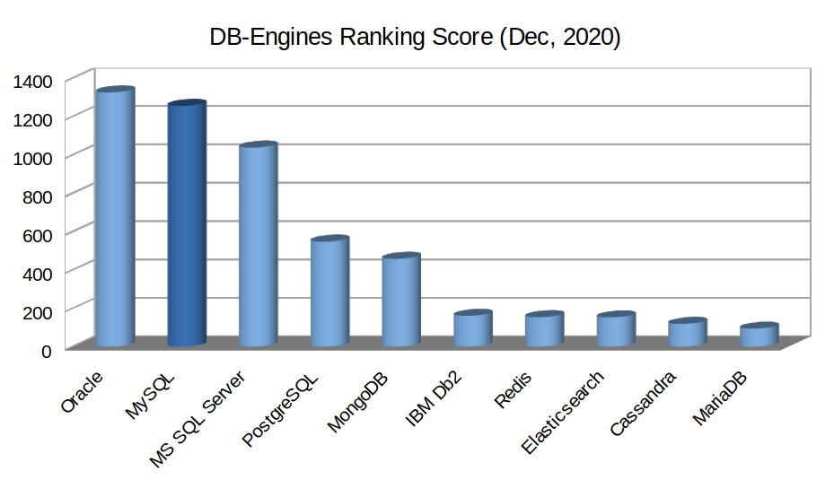

In this oracle offers high performance followed by MySQL and ends up with MariaDB

**speed and data latency: -**

In this also once again MySQL has high speed and latency. The next followed by Aws SQL and then by Oracle and so on.

**security:-**

for any database to be considered as secured these are the basic steps aspects that are required to grade the databases in comparison process, they are

Restricting unauthorized access

Load/stress testing and capacity testing of a database

Physical security of the database server and backup equipment

Reviewing the existing system for any known or unknown vulnerabilities

Data encryption can provide an additional layer of security to protect the integrity and confidentiality of data.

In terms of security the first three databases i.e., MySQL, MICROSOFT SQL SERVER, ORACLE are giving almost same kind of security features. The rest of the databases like postgre,DB2, redis and following are giving consistently less security compared to other databases.

**system compatibility, Scalability, capability of handling big data:-**

**system compatibility:-**

Compatibility is the capacity for two systems to work together without having to be altered to do so. Compatible software applications use the same data formats. That means virtue to perform the application irrespective of the configurations of the system.

**Scalability:-**

scalability is the ability of a database to handle changing demands by adding/removing resources. Databases have adopted a host of techniques to cope. That means the virtue of the application auto adjust to the work environment without any additional tools.

**Capacity to handle big data:-**

The name Big Data itself is related to a size which is enormous. Size of data plays a very crucial role in determining value out of data. Also, whether a particular data can actually be considered as a Big Data or not, is dependent upon the volume of data.

In this oracle , MySQL, MS-SQL server occupies almost equal places giving their best but among them oracle and MySQL are good in giving compatibility ,scalability and at handling big data.

**2. Compare column-based and row-based database: -**

The row based and column-based data bases coming from a same origin that is relational data base i.e., SQL based on the orientation of data stored.

**Column orientation Database**

It stores the data in column-wise.

The data will be stored in column after column that means in column by column wise.

It supports analytic query.

This type of data storage data system is mostly opted for the operations in the data like attributes, number of products, arithmetical and logical operations on the number of rows and statistical analysis always uses this column orientation database.

This allows the good computational speed when the operations on the data is needed.

This is being most used by most major providers of cloud data warehouses. For them this is the dominant architecture to support OLAP.(online analytical processing).

some of the data bases uses row wise are,

Click House

Big Query

Red Shift

**Row orientation Database**

It stores the data in row-wise.

The data will be stored row after row that means row by row wise.

It supports ACID transactions.

Frequent writes, CURD.

Operational databases and applications such as E-commerce use this row wise orientation of database.

This type allows the data base to write the data in row quickly.

In this the data append that means updating the data will be done at the end as a new row.

Hence this enables the user to write, read and append data very quickly.

This is most suitable for online transaction processing(OLTP) in operational applications.

some of the data bases uses row wise are,

MY SQL

ORACLE

Microsoft SQL server

Note:- To choose one of the data type either the row/column , if there is a need to improve the overall performance the data type chosen based on minimum number of data seeks evaluated.